2.2 Properties of Water
Key Concept: Water’s unique properties allow life to exist on earth.

Water is a Polar Molecule (polarity)
- Life depends on hydrogen bonds in water
- Polar molecules have slightly charged regions. H2O the oxygen in negatively charged and the hydrogen is positively charged. The opposites attract. Polar connects to polar.
- Non polar molecules (oil, fat) do not have charged regions.
Hydrogen bonds are responsible for 3 properties of water
- High specific heat
- Cohesion
- Adhesion

- Cohesion: Like substances adhere (stick) to like substances
- Adhesion: 2 different molecules attract
- High specific heat: heats up and maintains heat for extended periods
Many compounds dissolve in water (compounds: 2 different chemical s coming together).
- A solution is formed when one substance dissolves into another.
2 parts to a solution (tea, kool-aid etc)
- Solvents dissolve other substances
- Solutes dissolve in a solvent.
The worlds most used solvent is water.

Acids and Bases- pH scale

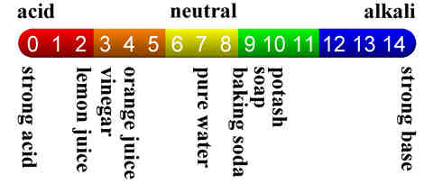
- A pH less than 7 is an acid
- 7 is neutral (neither an acid nor a base)
- A pH more than 7 is basic.

