2.5 Enzymes

2.5 Key Concept: Enzymes are catalysts for chemical reactions in living things.
A catalyst lowers activation energy
- Catalysts are substances that speed up chemical reactions
  - Decrease activation energy ( amount of energy needed to start a reaction)
  - Increase reaction rate
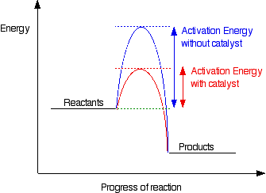

Enzymes allow chemical reactions to occur under tightly controlled conditions
- Enzymes are catalyst in living things
  - Enzymes are needed for almost all processes
  - Most enzymes are proteins.
Disruption in homeostasis can prevent enzymes from functioning
- Enzymes function best in a small range of conditions
- Changes in temperatures and pH can break hydrogen bonds.
- An enzyme function depends on its structure
An enzyme structure allow only certain reactants to bond to an enzyme.
- Substrates
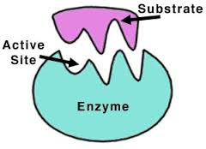
- Active site

The lock and key model help illustrate how enzymes function
- Substrates brought together
- Bonds in substrates weakened.

