7.1 Chromosomes and Phenotype
Key Concept: The chromosomes on which genes are located can affect the expression of traits.
Two types of autosomes genes affect out phenotype.
- Mendel studied autosomal gene traits, like hair texture.
Mendels rules if Inheritance apply to autosomal genetic disorders
- A heterozygote for a recessive disorder is a carrier
- Disorders caused by dominant alleles are uncommon.
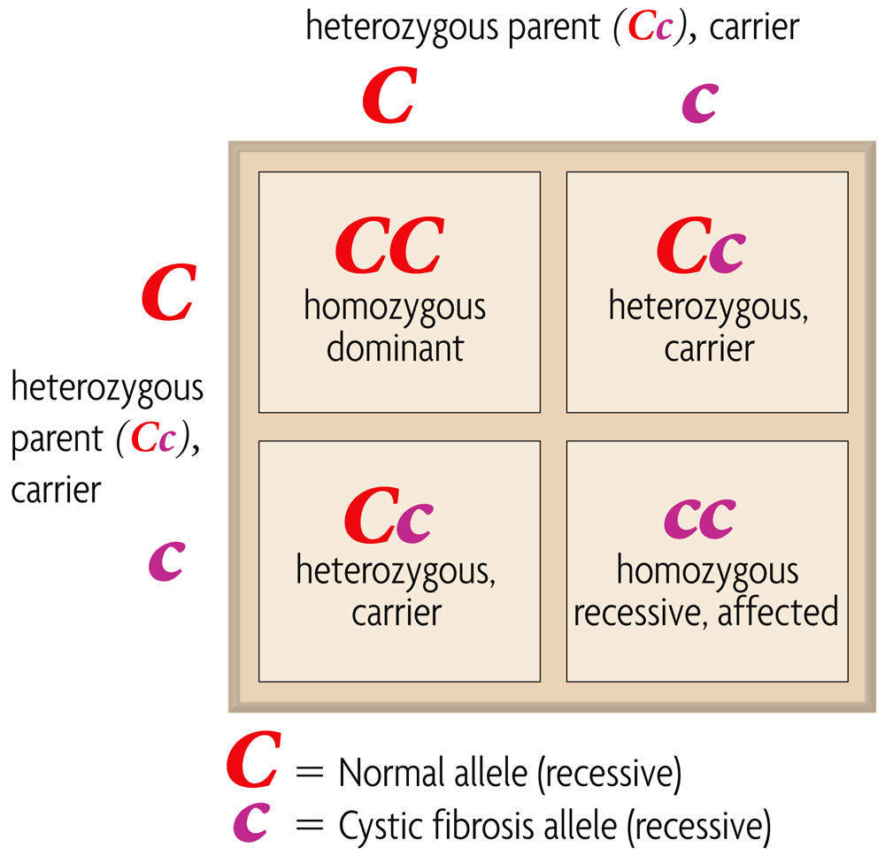
(dominant)

Males and Females can differ in sex-linked traits
- Genes n chromosomes are called sex linked genes.
  - Y chromosomes in mammals are responsible for male characteristics
  - X chromosomes genes in mammals affect many traits.
- Male mammals have an XY genotype
  - All of a males sex linked genes are expressed
  - Males have no second copies of sex linked genes.
Females mammals have an XX genotype.
- Expression of sex linked genes is similar to autosomal genes in females
- X chromosome inactivity randomly “turns off “ one X chromosome.

