7.4 Human Genetics and Pedigrees

Human genetics follows the patterns seen in other organisms.
- The basic principles of genetics are the same in all sexually reproducing organisms.
- Females (XX) can carry sex -linked genetic disorders. (X linked traits are the same as sex linked, females only carry the x)
- Males (XY) express all sex-linked genes.
- Expression of the disorder depends on which parent carries the allele (part of a gene) and the sex of the child.
- If the phenotype is more common in males, the genes are likely sex-linked.
- A Pedigree is a chart for tracing the genes in a family.
- An autosomal chart does not show sex-linked traits. (ex. Hemophilia, color blindness)
- 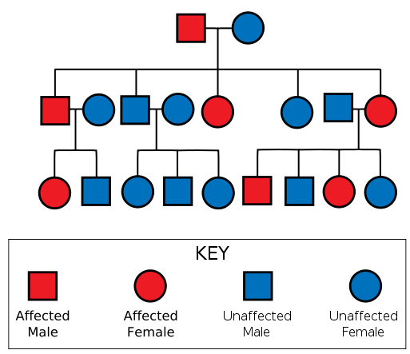
- Pedigree charts an also be used to trace sex-linked traits which are only attached to recessive genes.
- A karyotype is a picture of all chromosomes in a cell.

