8.3 DNA Replication
Key Concept: DNA Replication copies the genetic information of a cell.

Replication copies the genetic information:
- A single strand of DNA serves as a template for a new strand.
- The rules of base pairing direct replication
- DNA is replicated during the S (synthesis) stage of the cell cycle
- Each body cell gets a complete set of identical DNA.
Proteins carry out the process of replication
- DNA serves only as a template
- Enzymes and other proteins d the actual work of replication.
  - Enzymes unzip the double helix
  - Free –Floating nucleotides form hydrogen bonds with the template strand.
nucleotide
The DNA molecule unzips in both directions.
- DNA polymerase enzymes bond the nucleotides together to form the double helix.
- Polymerase enzymes form covalent bonds between nucleotides in the new strand.
- Two new molecules of DNA are formed, each other with an original strand of DNA and a newly formed strand.
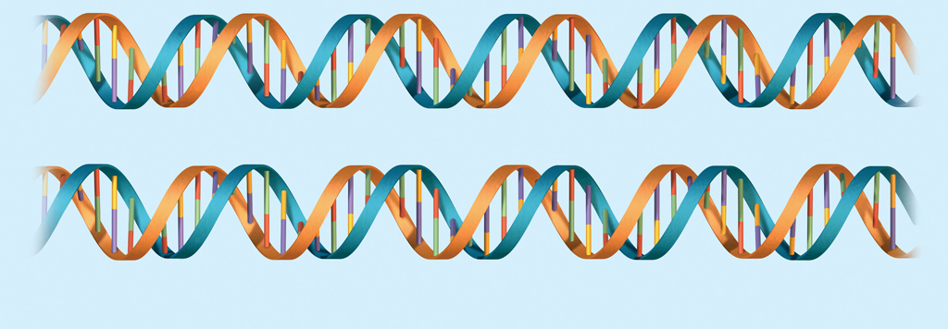
- DNA replication is semiconservative.
original strand
new strand
Two molecules of DNA

